**Study Notes:**

## **Understanding Auto Layout**

Auto Layout dynamically calculates the size and position of all the views in your view hierarchy, based on constraints placed on those views.

For example, you can constrain a button so that it is horizontally centered with an Image view and so that the button’s top edge always remains 8 points below the image’s bottom. If the image view’s size or position changes, the button’s position automatically adjusts to match.

This constraint-based approach to design allows you to build user interfaces that dynamically respond to both internal and external changes

**External Changes**

External changes occur when the size or shape of your superview changes. With each change, you must update the layout of your view hierarchy to best use the available space. Here are some common sources of external change:

* The user resizes the window (OS X).
* The user enters or leaves Split View on an iPad (iOS).
* The device rotates (iOS).
* The active call and audio recording bars appear or disappear (iOS).
* You want to support different size classes.
* You want to support different screen sizes.

Most of these changes can occur at runtime, and they require a dynamic response from your app.

### Internal Changes

Internal changes occur when the size of the views or controls in your user interface change.

Here are some common sources of internal change:

* The content displayed by the app changes. When your app’s content changes, the new content may require a different layout than the old
* The app supports internationalization.
* The app supports Dynamic Type (iOS), in this the user can change the font size used in your app.

### Auto Layout Versus Frame-Based Layout

There are three main approaches to laying out a user interface.

* You can programmatically lay out the user interface,
* You can use autoresizing masks to automate some of the responses to external change,
* You can use Auto Layout.

Traditionally, apps laid out their user interface by programmatically setting the frame for each view in a view hierarchy. The frame defined the view’s origin, height, and width in the superview’s coordinate system.

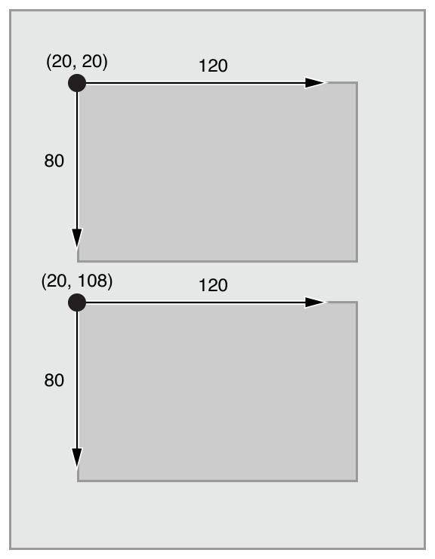

Although **autoresizing** masks are just an iterative improvement on programmatic layouts.

**Auto Layout** defines your user interface using a series of constraints.

Constraints typically represent a relationship between two views.

Auto Layout then calculates the size and location of each view based on these constraints.

This produces layouts that dynamically respond to both internal and external changes.

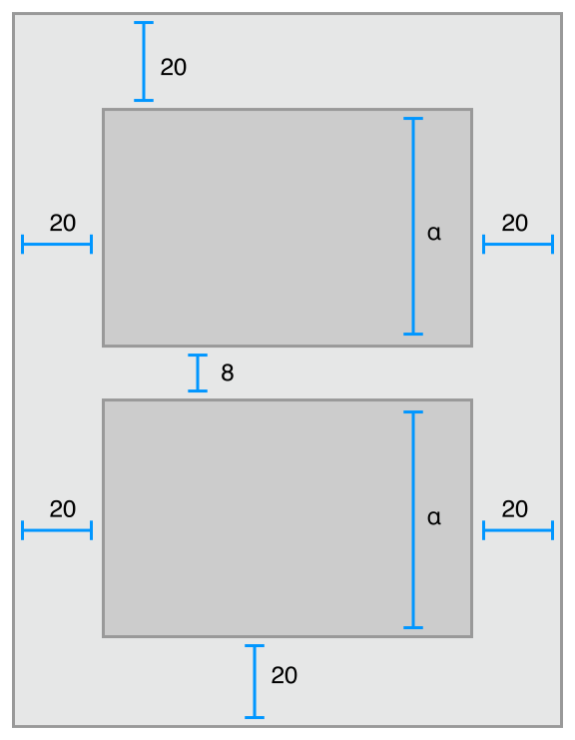

## **Auto Layout Without Constraints**

Stack views provide an easy way to leverage the power of Auto Layout without introducing the complexity of constraints. A single stack view defines a row or column of user interface elements. The stack view arranges these elements based on its properties such as orientation, spacing and alignment.

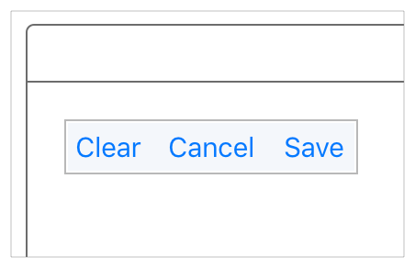

Additionally, you can nest stack views inside other stack views to build more complex layouts.

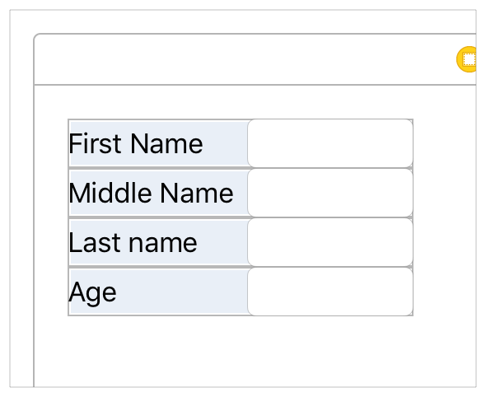

### Auto Layout Attributes

In Auto Layout, the attributes define a feature that can be constrained.

In general, this includes the four edges (leading, trailing, top, and bottom), as well as the height, width, and vertical and horizontal centers. Text items also have one or more baseline attributes.

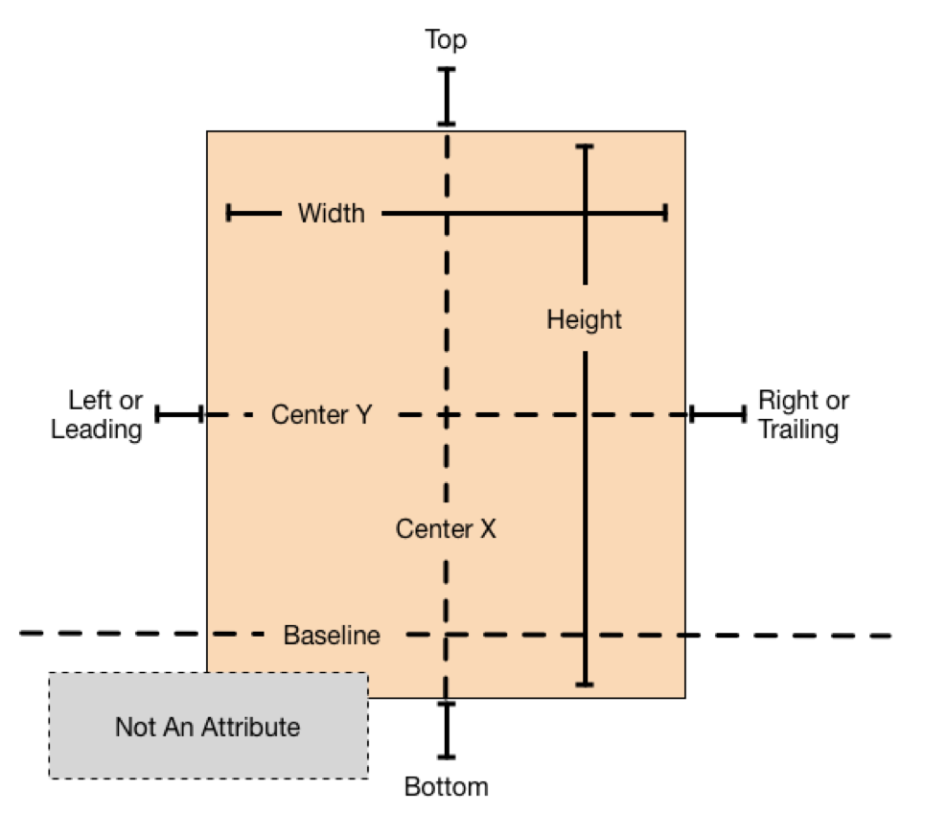

### Using the Stack, Align, Pin and Resolve Tools

Interface Builder provides four Auto Layout tools in the bottom-right corner of the Editor window. These are the Stack, Align, Pin, and Resolve Auto Layout Issues tools.

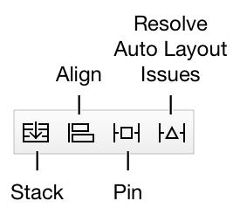

### Stack Tool

* The Stack tool allows you to quickly create a stack view.
* Select one or more items in your layout, and then click on the Stack tool.
* Interface Builder embeds the selected items in a stack view and resizes the stack to its current fitting size based on its contents.

### Align Tool

The Align tool lets you quickly align items in your layout. Select the items you want to align, and then click the Align tool. Interface Builder presents a popover view containing a number of possible alignments.

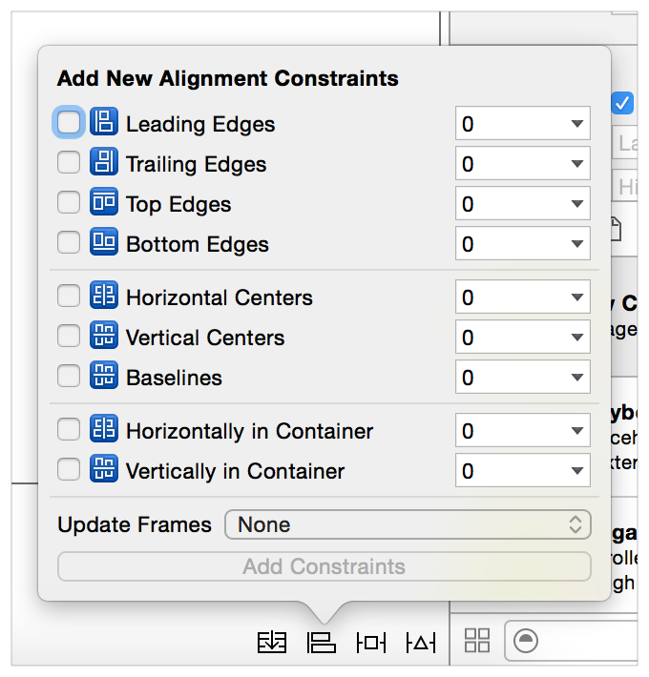

Select the options for aligning the selected views, and click the Add Constraints button. Interface Builder creates the constraints needed to ensure those alignments.

By default, the constraints do not have any offset (the edges or centers are aligned with each other) and none of the frames are updated when the constraints are added. You can change any of these settings before creating the constraints.

You typically select two or more views before using the Align tool. However, the Horizontally in Container or Vertically in Container constraints can be added to a single view. You can use the popover to create any number of constraints at once—though it rarely makes sense to create more than one or two at a time.

For more information, see Adding Auto Layout Constraints with the Pin and Align Tools in Auto Layout Help.

### Pin Tool

The Pin tool lets you quickly define a view’s position relative to its neighbors or quickly define its size. Select the item whose position or size you want to pin, and click the Pin tool. Interface Builder presents a popover view containing a number of options.

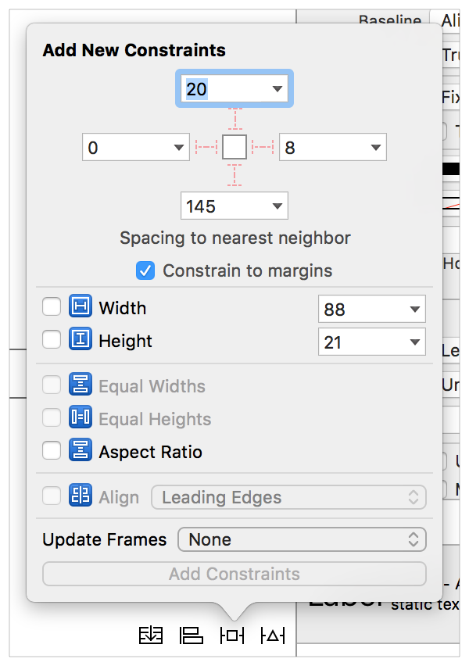

The top portion of the popover lets you pin the selected item’s Leading, Top, Trailing, or Bottom edge to its nearest neighbor.

The associated number indicates the current spacing between the items in the canvas. You can type in a custom spacing, or you can click the disclosure triangle to set which view it should be constrained to or to select the standard spacing. The “Constrain to margins” checkbox determines whether constraints to the superview use the superview’s margins or its edges.

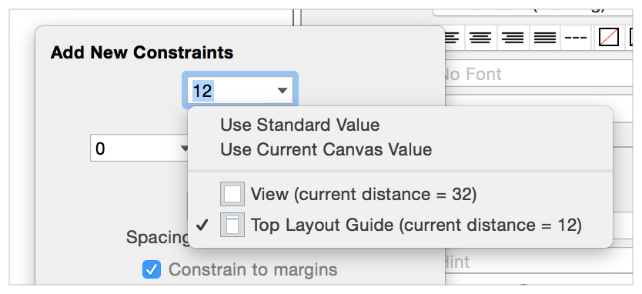

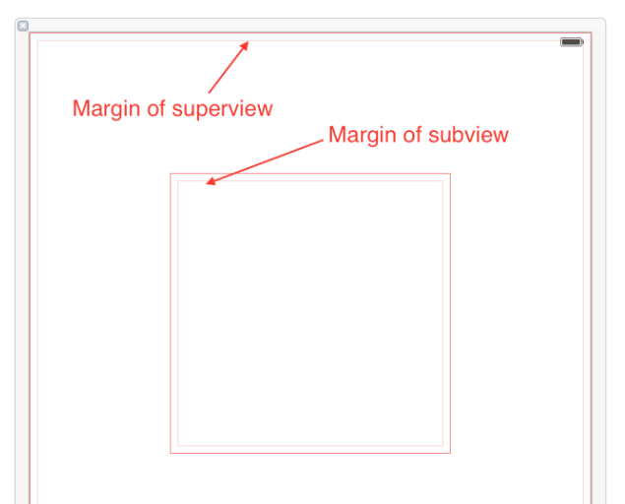

The lower portion of the popover lets you set the item’s width or height. The Width and Height constraints default to the current canvas size, though you can type in different values.

The Aspect Ratio constraint also uses the item’s current aspect ratio; however, if you want to change this ratio, you need to review and edit the constraint after creating it.

Typically, you select a single view to pin; however, you can select two or more views and give them equal widths or equal heights. You can also create multiple constraints at once, or you can update the frames as you add the constraints. After you’ve set the options you want, click the Add Constraints button to create your constraints.

### 

### Resolve Auto Layout Issues Tool

The Resolve Auto Layout Issues tool provides a number of options for fixing common Auto Layout issues. The options in the upper half of the menu affect only the currently selected views. The options in the bottom half affect all views in the scene.

